

CSF3133 WEB-BASED INTERFACE DESIGN (K4)
LAB MODULE 3
SEMESTER III 2025/2026

PREPARED BY:
AIDA HUSNA BINTI MUHAMAD ZAIDI

NO MATRIK:
S76103

LECTURER:
TS. DR. WAN NURAL JAWAHIR BINTI HJ WAN YUSOF

LAB MODERATOR:
PN. WAN FATIN FATIHAH BINTI YAHYA

3.2 Block and Inline Elements
Output
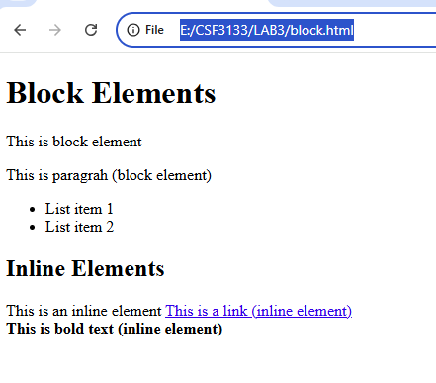

3.2 Using <div> to Organize Content
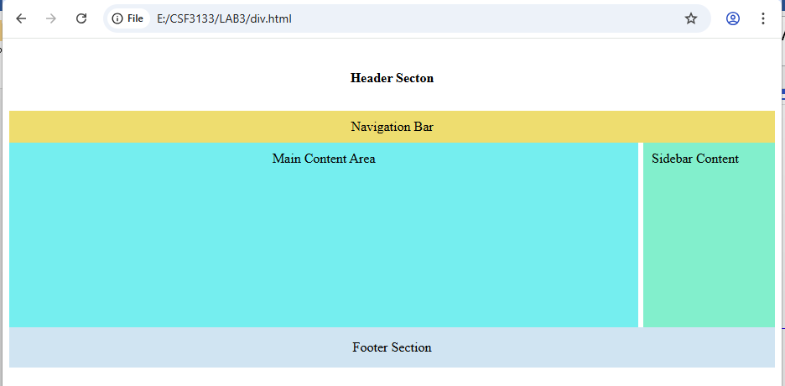

3.4 Understanding HTML Entities
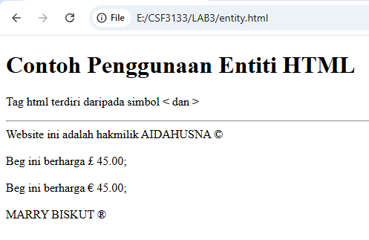

3.5 Hypertext Mark Up Language 5 (HTML5)
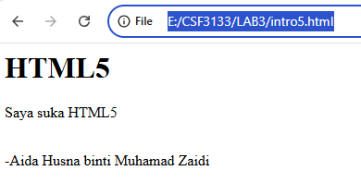
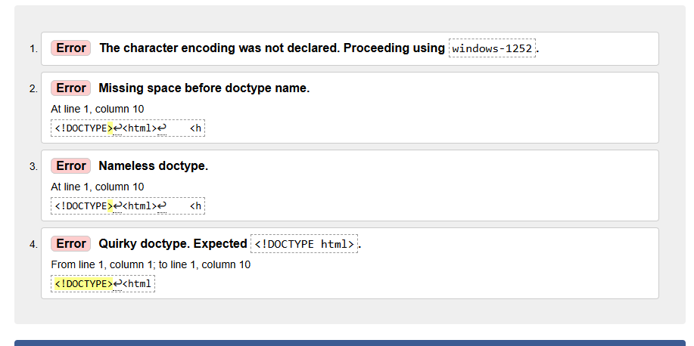
3.6 Form Element in HTML5
3.6.1 Input Elements in HTML5
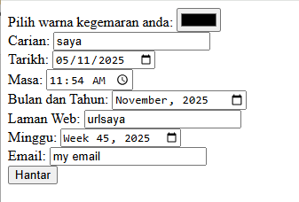
Output after click ‘Hantar’
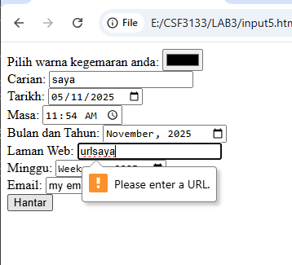

3.6.2 Attributes for Input HTML5
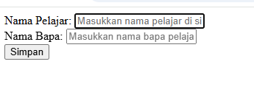

After fill in ‘Amen’ value in ‘Student Name’ and leave it blank in ‘Father Name’ column.
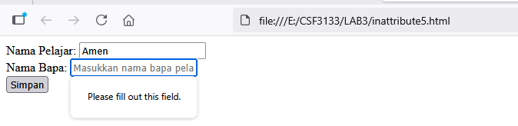
After enter letter ‘A’ into ‘Student Name’ box.
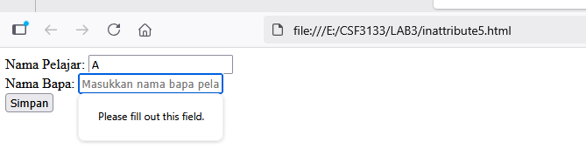
3.6.3 HTML5 <output> element
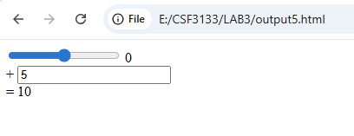

Lab Exercise
